 | CHAROTAR UNIVERSITY OF SCIENCE & TECHNOLOGY  DEVANG PATEL INSTITUTE OF ADVANCE TECHNOLOGY AND RESEARCH | 

Weekly Report
In this report students require to mention the work has been done during the week and planning for the next week. (Please fill individual report for each week)

Student ID: 18dce057 | Student Name: Shraddha Mehta
From Date:08/05/2020 | To Date:16/05/2020
Semester: 4 | Internship ID: 30

Work done in last week (Attach supporting Documents):

1 . I have made admin category activity

It is basically home activity for an admin or shop keeper which is having options to add new product whether it is fruit or vegetable or chocolates etc..
It is also having three buttons for maintain product which will lead to maintain product activity , check new order button which will lead to check new order activity and logout button.

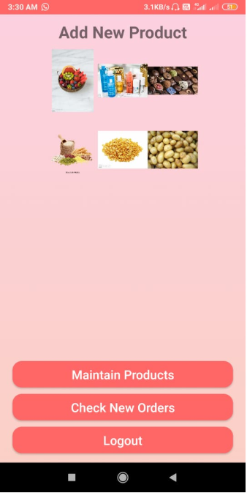

- I have made an adminaddnewproduct activity
Here admin can add new products like admin can add image of item, name of item , details of item and price of item..

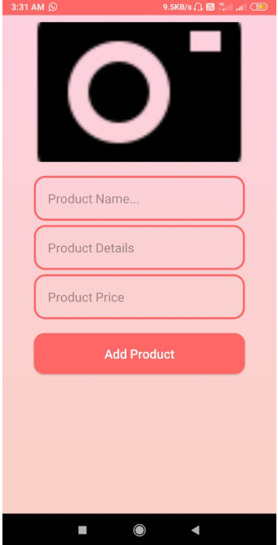 | 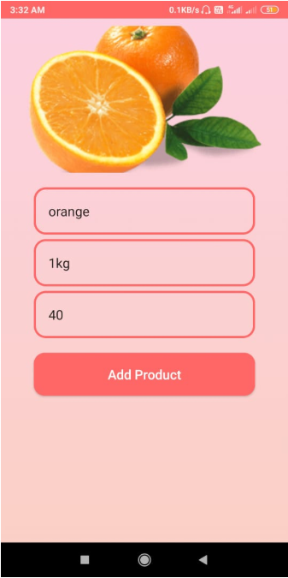

This is snapshot of home activity where added item orange is available for user…

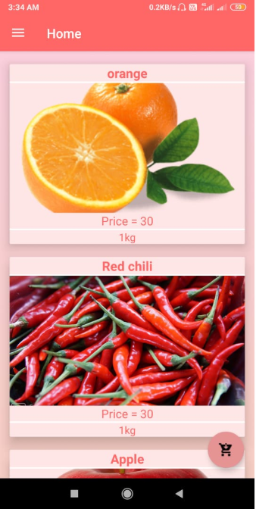

- I have made an adminmaintainproduct activity

This is very useful for admin where admin can modify name of item or admin can change price of item or admin can modify details of item or admin can delete that particular item...
Here I am changing price of oranges from 40 to 30…

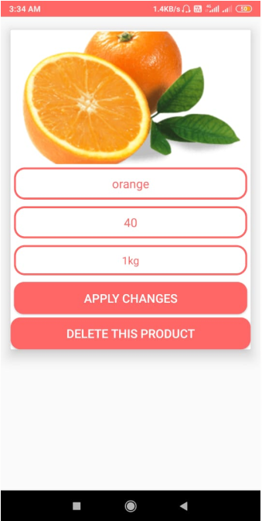 | 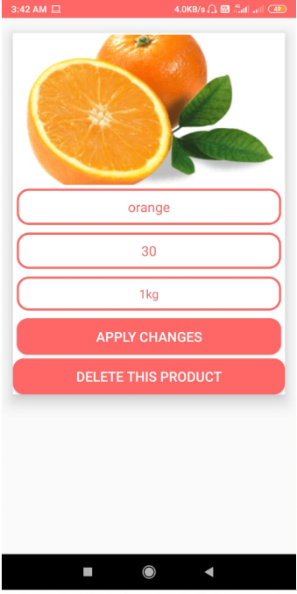

After changing price of orange it will automatically reflect to home Activity where user can find new price of an orange..
Here we can see the price of orange are 30 now…
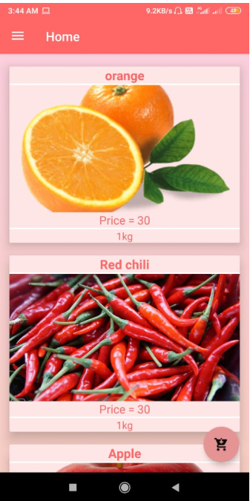

- I have made check new order activity for an admin

With help of this Activity Admin can verify orders… it will show name, phone number , amount and etc details of user …If order was placed then Admin can select yes in dialog box after that user is able to buy new products…

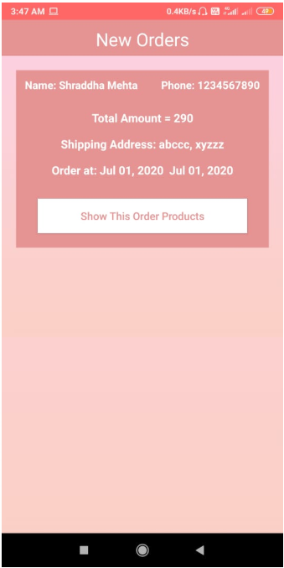 | 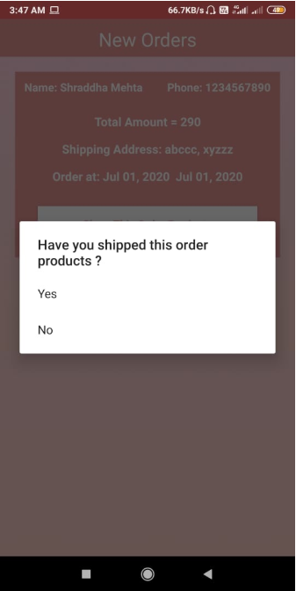

- I have made settings activity for user

Here user can update their profile like profile photo,phone number, name and address ..

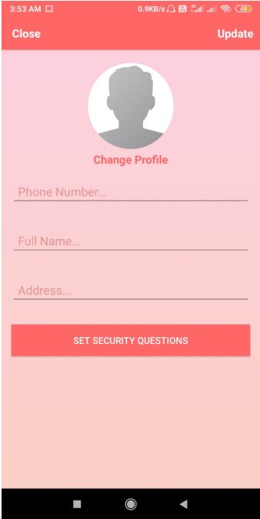 | 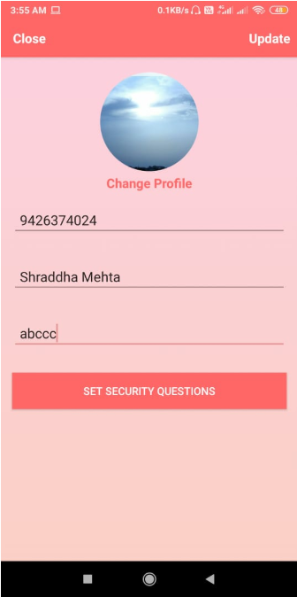

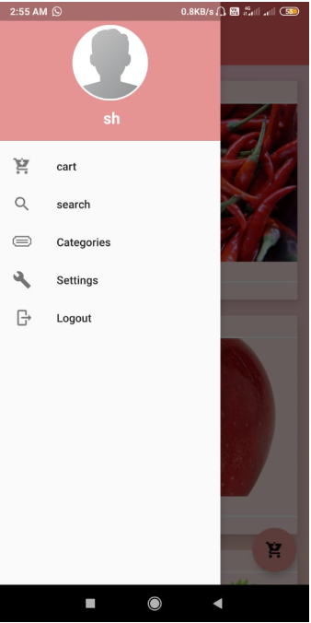 | 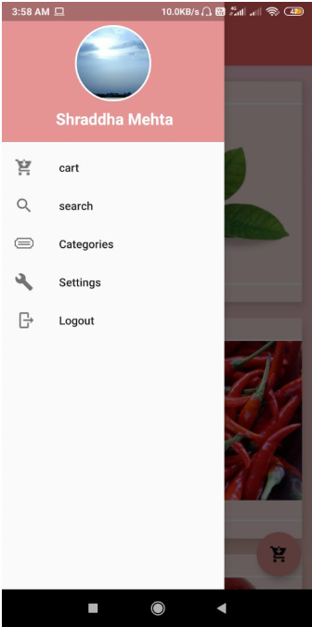

Here user can set security question it is very useful for reset password Feature with help of this user can recover their password…

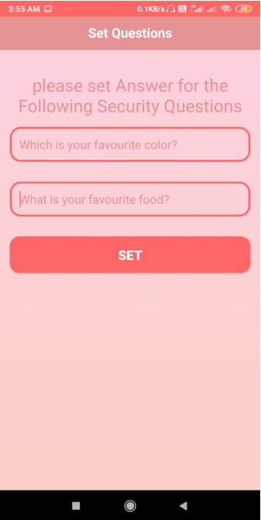 | 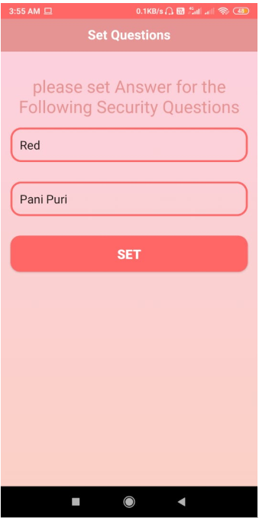

Plans for next week:

1. I will add feature of forgot password which will be very supportive and beneficent to recover password.
2. I will make search product Activity which will helpful for user to find particular grocery item.
3. I will complete my project.

References:

https://developer.android.com/guide/topics/ui/dialogs

https://code.tutsplus.com/tutorials/android-sdk-working-with-picasso--cms-22149#:~:text=Picasso%20is%20an%20image%20library,displaying%20images%20from%20external%20locations.

https://vasundharavision.com/blog/android/crop-image

toastshttps://developer.android.com/guide/topics/ui/notifiers/

https://developer.android.com/training/multiscreen/screensizes

Signature of External Supervisor Signature of Internal Supervisor

